City back to work on permanent Open Restaurants plans following court ruling

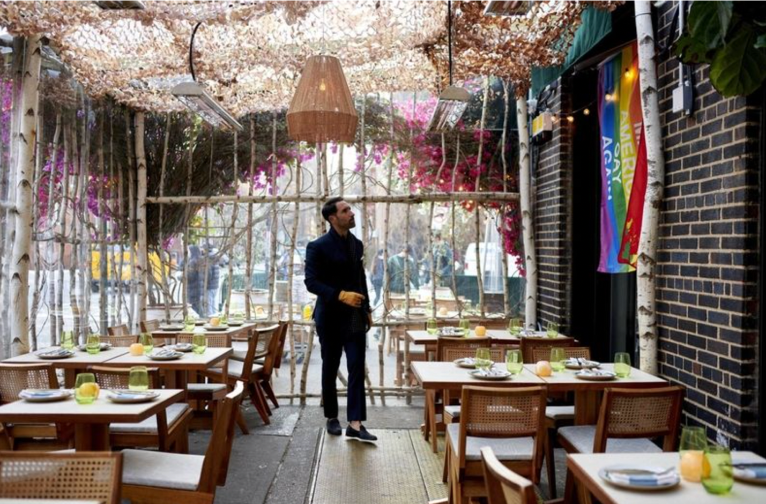
New York City is once again planning the design and rules for permanent outdoor seating at restaurants following a legal decision in one of the open cases that has challenged the program.
“This ruling is great news for New York City’s comeback,” Mayor Eric Adams wrote in a tweet following an order from a panel of state appellate judges.
The order overturned a March ruling, which required that the city complete a full environmental review, rather than the shorter statement it had provided to the City Council to pass a necessary zoning amendment.
Putting the full review together could have taken several months, urban planner George Janes, who provided affidavits for the plaintiffs, told Crain’s at the time.
But the city argued in an appeal that it made no sense to use the temporary pandemic-era program as the basis for an environmental review, since the nature of the permanent program would be sufficiently different and has not been finalized.
The appellate judges appear to have taken that argument seriously.
“The city’s issuance of the SEQRA [environmental review] negative declaration was not an act that itself inflicts actual, concrete injury,” they wrote.
The Coalition United for Equitable Urban Policy, a group of residents that brought the lawsuit, said the ruling left the door open to future action. The judges focused in part on the early timing of the suit but did not dispute the group’s basic claims that restaurants’ outdoor areas had affected residents’ quality of life because of noise, privacy and accessibility, the coalition said.
“The decision merely puts off the inevitable,” said Michael Sussman, attorney for the group. He said he would appeal the decision.
A second lawsuit, which challenges Open Restaurants’ reliance on Adams’ ongoing emergency orders, is awaiting a hearing.
While the environmental-review case was moving through the court, the rest of the planning process stalled, including a series of design, public engagement, administrative and legislative steps overseen by the city Department of Transportation. Originally, the city’s schedule targeted the winter of 2022 to publish a final manual of design guidance and a digital application for restaurant owners.
Now, the DOT and the Department of City Planning “are hard at work designing a permanent outdoor dining plan that will allow us to transition from the emergency structures,” according to a tweet sent Thursday by the latter.
The next steps for the program are the same as they were in the spring, and there are no updates on timing, DOT spokesman Vincent Barone said: First, the City Council would have to pass legislation, then the rulemaking process could proceed.
The Alfresco NYC Coalition, an umbrella group composed of three groups advocating for the permanent program—Design Trust for Public Space, the Regional Plan Association and the Tri-State Transportation Campaign—praised the appellate ruling.
“Open Restaurants have taken cars off our streets and saved tens of thousands of jobs in an industry devastated by the pandemic,” they said in a statement. “We look forward to working with the Adams administration and the City Council to find thoughtful and sustainable ways to transition Open Restaurants to a permanent city program that benefits all communities.”

